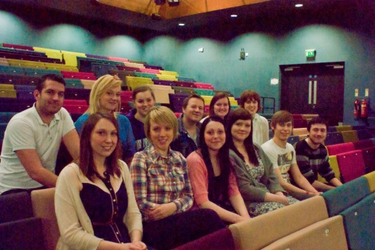

**Acknowledgements**Taylor and Watt Design – For documenting our process.  
  
Lincoln City Football ground – For their kind donation of a rehearsal room.  
  
Sugarcubes – For advertising our company.  
  
Theatre Royal – For the donation of Props.

Sarah Harrison – For styling the actors’ Hair and Make-up.

“Can you really know what you can’t see?”

Progeny Theatre Company presents their debut performance *A Gothic Tale*, an adaptation of Angela Carter’s *The Bloody Chamber*. Expect a visually stunning piece of theatre, which creates an impression of standing on the threshold between two worlds.  
It is a corrupted fairy tale, challenging the traditions and expectations we have come to expect from "Once Upon A Time", and tells the story of what comes after the "Happily Ever After". When the fairy tale world slowly becomes corrupted and cracks begin to show, we are forced to question if any innocence can remain.  
This performance is intended for adult audiences only (16+). It contains violence and scenes of a sexual nature.

Sunday 19th May  
LPAC  
7:30pm

**A Gothic Tale**

Presents

**Director’s Foreword**  
*A Gothic Tale* presents a corrupted, challenging and sometimes uncomfortable version of reality versus fantasy. It ignites controversy, excites the senses and corrupts the imagination. Progeny Theatre’s first production, the play creates a world which combines the infinitely fantastic and the absolutely grotesque. *A Gothic Tale* asks us to question what we regard as truly monstrous.

Jamie Barber  
Producer

Stephanie Doe  
Director

Kate Dawson  
Production Manager

Alex Urbanczyk  
Stage Manager

Hannah Smith  
Housekeeper

Kelsey Stirling  
Ex-Wife

Ellie Richards   
Set Designer

Robert Bull  
DSM

**Crew**

Jessica Smith  
Snow Child

Gary Richardson  
Piano Tuner

Lewis Chanel  
Count

Francesca Simeoli   
Countess

**Cast**